PART A: SYSTEM DOCUMENTATION

Module Code:CSE202

Module Title: Object Oriented Analysis & Design with Java

Assignment Title: Part A - Requirements Elicitation and UML Modelling

Student Name: Abednigo Ketshephaone Titus

Student ID:CSE24-069

Date of Submission:

WEEK Sep. 08 – 12: Requirements Elicitation (10 marks)

1.1 Functional Requirements (5 marks)

The Banking System is designed to manage customer accounts and transactions efficiently. Based on the scenario and client discussions, the system shall provide the following core functionalities:

1. Customer Registration and Management:

• The system shall allow a new customer to be registered by capturing their personal details, including first name, surname, physical address, and contact information.

• For customers opening a Cheque Account, the system must additionally capture their employment details (company name and company address).

2. Account Lifecycle Management:

• The system shall allow a registered customer to open one or more accounts of the following types:

• Savings Account: Designed for depositing funds for future use. This account type does not permit withdrawals. It shall accrue a monthly interest of 0.05% on the available balance.

• Investment Account: An interest-bearing account that requires a minimum initial deposit of BWP 500.00 to be opened. It allows both deposits and withdrawals. It shall accrue a higher monthly interest of 5% on the available balance.

• Cheque Account: Primarily used for salary credits. It allows both deposits and withdrawals. It can only be opened for a customer who provides valid employment information.

• The system shall allow a customer to view a list of all their accounts and their current balances.

3. Transaction Processing:

• The system shall allow a customer to deposit funds into any of their active accounts.

• The system shall allow a customer to withdraw funds from their Investment or Cheque accounts, provided the withdrawal amount does not exceed the available balance.

• The system shall automatically calculate and apply the appropriate monthly interest (0.05% for Savings, 5% for Investment) to each eligible account.

4. System Access Control:

• The system shall provide a secure login mechanism to authenticate customers and ensure that users can only access their own accounts and data.

Appendix: Mock Interview Record

• Interviewer: Abednigo Titus, Systems Analyst

• Interviewee: Kentsenao Baseki, Client Representative

• Date: 10 September 2025

Purpose: To clarify and confirm the functional requirements of the Banking System.

Key Discussion Points and Outcomes:

• Q: Who are the primary users of the system?

• A: The primary users are the bank's customers. Bank staff who manage the backend data are considered secondary users but are out of scope for this initial version.

• Q: Can a single customer have multiple accounts?

• A:Absolutely. A key requirement is that one customer can hold multiple accounts of different types (e.g., one Savings, one Investment, and one Cheque account).

• Q: What are the specific rules for opening an Investment account?

• A: The rule is strict. An Investment account cannot be opened unless the initial deposit is at least BWP 500.00. This must be enforced by the system.

• Q: How should the system handle interest payments?

• A: Interest should be applied automatically on a monthly cycle. The different rates (5% for Investment, 0.05% for Savings) must be configurable within the account objects. Cheque accounts do not earn interest.

• Q: Is there a requirement for tracking transaction history?

• A: Yes, for auditability. While not a primary focus for the GUI initially, the system must log all transactions (deposits, withdrawals, interest applications) in the database.

1.2 Non-Functional Requirements (5 marks)

The following non-functional requirements define the quality attributes and constraints of the Banking System:

1. Security:

• The system must ensure the confidentiality and integrity of all customer data.

• Customer passwords must be hashed and salted before storage in the database.

• All transaction operations must be recorded in an audit log to ensure non-repudiation.

2. Usability:

• The graphical user interface (GUI) must be intuitive, user-friendly, and require minimal training to use. Menu options and buttons should be clearly labeled.

3. Reliability and Availability:

• The system must be robust and available for use during extended business hours. Core functions like deposits and withdrawals must be highly reliable.

4. Performance:

• The system should respond to user inputs (e.g., button clicks) in a timely manner. Key operations must be completed within 2-3 seconds to ensure a smooth user experience.

5. Maintainability:

• The system's codebase must be well-structured, commented, and adhere to object-oriented design principles. This will facilitate future updates, bug fixes, and the addition of new features.

WEEK Sep. 08 – 12: Structural UML Modelling (20 marks)

2.1 System Use Case Diagram (10 marks)

Purpose: The Use Case Diagram depicts the system's functionality from the user's (actor's) perspective. It shows the interactions between the external actors and the use cases (system functionalities) that the Banking System must provide.

2. Structural UML Modelling

2.1. System Use Case Diagram

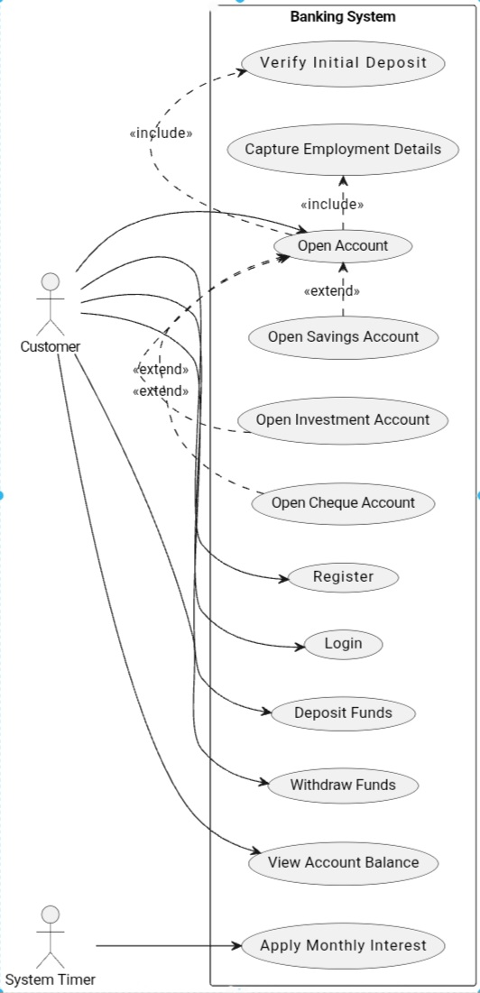

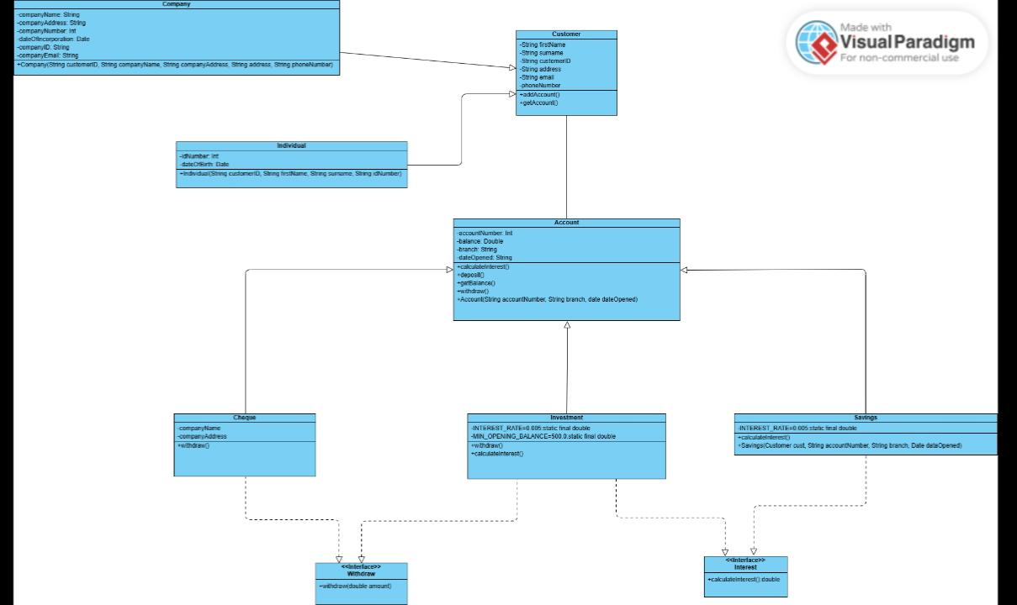2.2. Class diagram

3. Behavioural UML Modelling

3.1. Login and Deposit Sequence Diagrams:

a) Sequence Diagram for "Login"

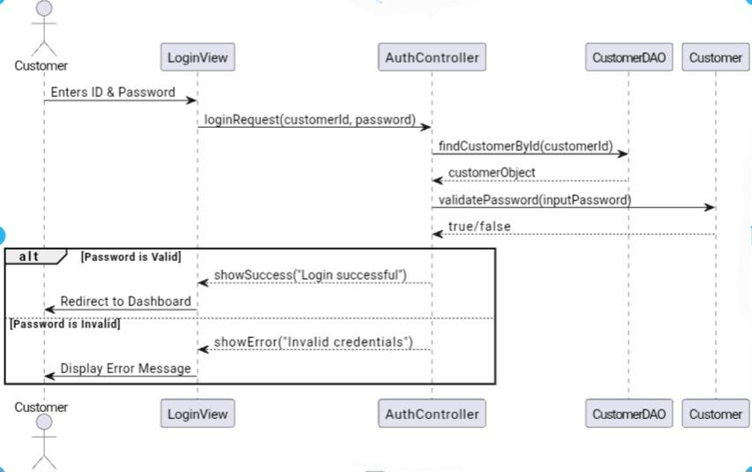

b) Sequence Diagram for “Deposit Funds

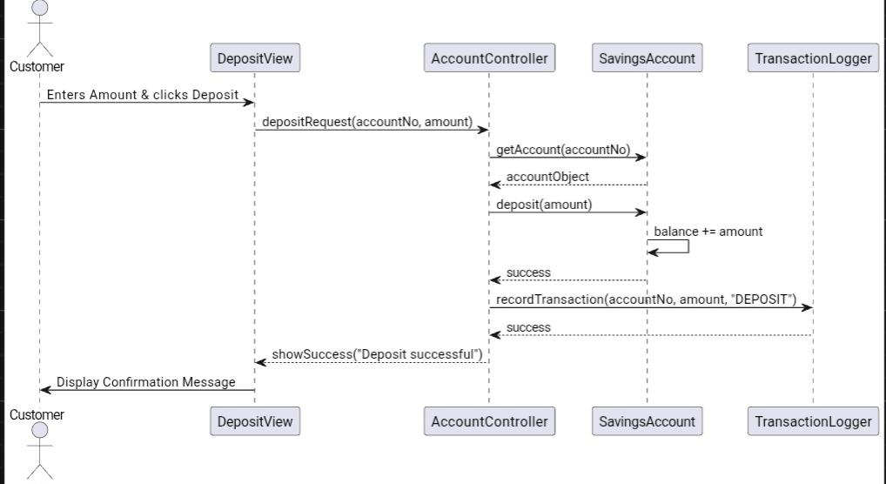

3.2. State Diagram:

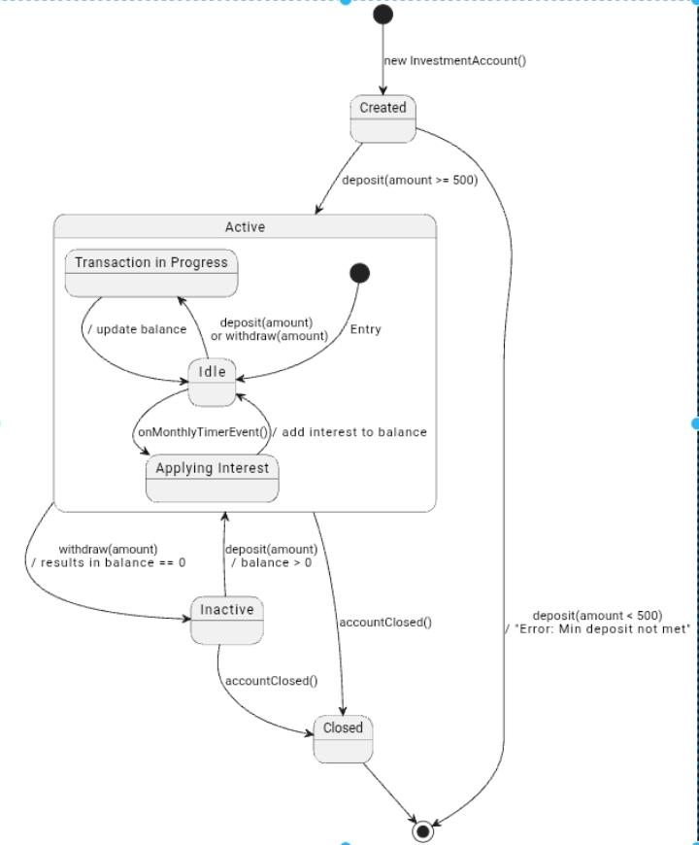State Diagram for “InvestmentAccount”

Meeting record appendix:

<https://mybac.sharepoint.com/sites/20252026cse202objectorientedanalysisanddevelopmentwithjav/Shared%20Documents/General/Recordings/OOAD%20Elicitation%20Session-20250918_103316-Meeting%20Recording.mp4?web=1>